**Download and Install XAMPP**

Go to the following URL and download xampp for your operating system:

https://www.apachefriends.org/download.html

I downloaded this version 5.6.12 / PHP 5.6.12

Next, click on the xampp-..... downloaded exe file

Just leave the components that are selected. Note: both PHP, MYsql and apache must be selected.

then just keep clicking next. When you come to the folder where to install xampp, it must be C:\xampp.

**Install the SHOT Application Source**

Next, retrieve the source for the SHOT application from our Git repository (https://github.com/paddyo7715/SHOT-Application.git) and copy the SHOT_System folder under the following folder on your PC:

C:\xampp\htdocs

**Install MySQL Workbench**

Note: To interface with MySQL, I use MySQL Workbench 6.3. I like it because it allows you to use a GUI to access MySQL. If you don’t wish to use the workbench then you can just use the command prompt.

You can get MySQL workbench at the following URL:

<https://dev.mysql.com/downloads/workbench/>

If I remember correctly the install required .NET to be installed on my PC, so it can be tricky.

**Start Apache and MySQL in XAMPP**

Start the xampp control panel (it will be in your start menu under xampp). And start the Apache module and MySQL by clicking on the start button under action.

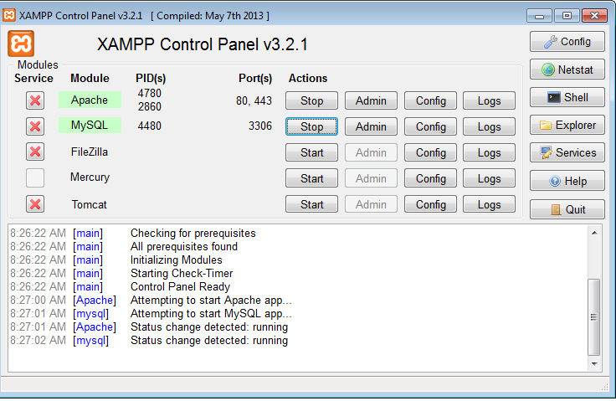

**Import the SHOT Database Dump File into Your Local MySQL Instance**

Note: Before beginning the database import process, be sure that you have saved the dumpSHOTDB.sql to your hard drive.

Next, let’s import the database data dump file, so that you will have the SHOT database on your PC.

Start MySQL Workbench and click on the local mysql server link on the home tab. This is the MySQL instance that is running from XAMPP under the root user id.

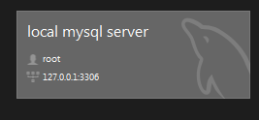

Now you should see the Navigator panel on the left hand side of the screen. If you don’t then select View – Panels – Hide Sidebar

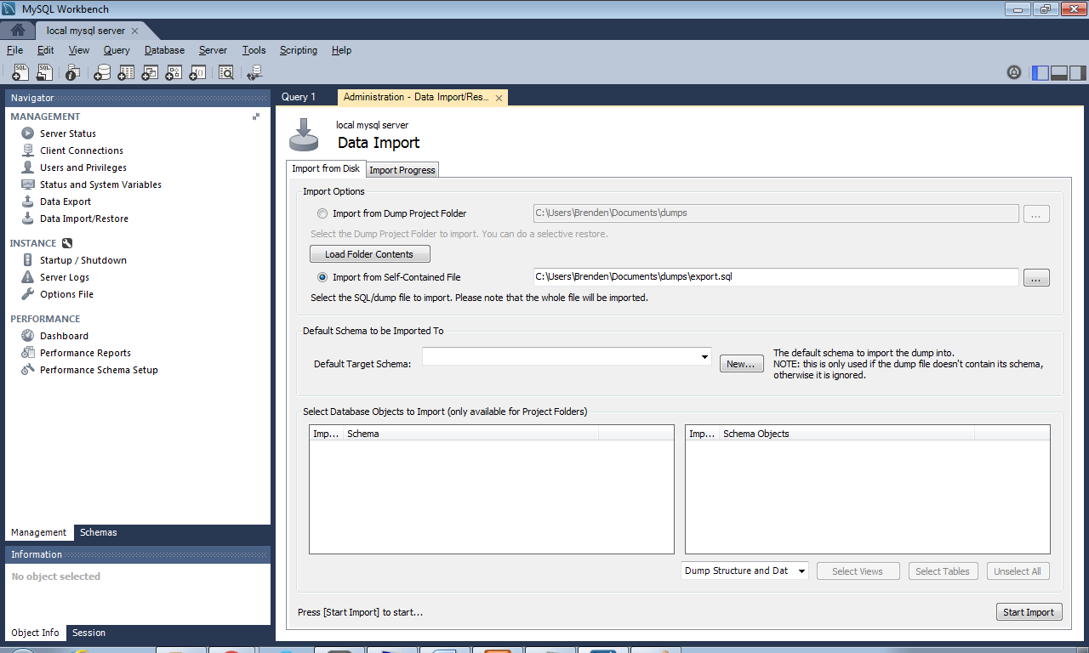

Be sure that Management is selected and not schemas.

Click Data Import/Restore

Select Import from Self Contained File

Select the path to the SHOT database dump .sql file dumpSHOTDB.sql

Then click the Start Import button

Once the database file is imported, you should be able to click on schemas in the Navigator panel to see the new database created. I believe the name of the database will be f15-cs691-shot. At this point the only user that will have access to the database is root.

**Add a user account to access the Database**

Rather than use the root to access the database, it is better practice to create a user account for this purpose.

Note: Please make note of the user id and password of the database user that you will be creating in the next step, as you will need to update a file with these values.

In MySQL Workbench, go back to Management in the Navigator panel and click Users and Privileges.

Click Add Account

Enter a login name and password

Limit to Hosts Matching: localhost

Click the administrative roles tab and select all roles.

Click on the Schema Privileges tab and click Add Entry

Select Selected Schema and select f15-cs691-shot from the drop down list box and click OK

Then highlight the new schema; it will have no privileges and click select all and then click Apply.

You should also delete the anonymous user, as I think this prevented me from logging in with the new userid.

Update the SHOT SessionStart.php file with the database connection info for your local database.

Update file C:\xampp\htdocs\SHOT_System\app\php\ SessionStart.php as follows:

dbUser and dbPW should be the user id and password that you just created in MySQL Workbench

<?php

session_start();

$_SESSION["dbServer"] = "127.0.0.1";

$_SESSION["dbUser"] = "xxxxxxxxx";

$_SESSION["dbPW"] = "xxxxxxxxx";

$_SESSION["dbDatabase"] = " f15-cs691-shot";

header("Location: ../../app.html");

?>

**Running the SHOT Application**

Start Internet Explorer, Chrome or Firefox and paste the following in the URL. The user interface will come up.

<http://localhost/SHOT_System/index.html>

Note: Apache and MySQL need to be started in XAMPP in order for you to run the SHOT Application.